

|  |
| --- |
| Master Document  Sprint 3 |
|  |
| 28/05/21 – 04/06/21  ICED COFFEE  Authored by: Bayley Wise and Kyle Chamberlain |

# 2,759 Iced coffee Vectors, Royalty-free Vector Iced coffee Images | Depositphotos®

Contents

1

Source Control Snapshot 28/5 – 4/6 5

1 Introduction 6

1.1 Scope 6

1.1.1 In Scope 6

1.1.2 Out of Scope 6

1.2 Quality Objective 6

1.3 Roles and Responsibilities 6

2 Test Methodology 6

2.1 Overview 6

2.2 Bug Triage 7

2.3 Suspension Criteria and Resumption Requirements 7

2.4 Test Completeness 7

3 Test Deliverables 7

4 Resource & Environment Needs 7

4.1 Testing Tools 7

4.2 Test Environment 8

5 Sprint One Meeting Minutes 1

In Attendance 1

Approval of Minutes 1

Adaptive Versus Responsive 1

Source Control Snapshot 1

Project Management Plan 1

Testing Plan 1

Analysis Report 1

Client Meeting 1

Sprint Report 2

6. Adaptive Versus Responsive 3

Adaptive Design 3

Responsive Design 3

What is to be used for this application 3

7. CITE Business Rules for Software Development 4

8. CITE Managed Services Quality Assurance 4

9. Acme Entertainment Pty Ltd Development Requirements 5

Project Management 6

Gannt Chart 6

Trello (Kanban Board) 6

Client meeting Notes 7

CITE Manager Notes 7

Source Control Snapshot 04/06 – 11/06 8

1 Introduction 9

1.1 Scope 9

1.1.1 In Scope 9

The signup will not require a password but there must be an option to remove their subscription. The removal process should send an email to the administrator requesting the removal of a member’s details from the database. Create a membership page to add new records to a membership database 9

1.1.2 Out of Scope 9

1.2 Quality Objective 9

1.3 Roles and Responsibilities 9

2 Test Methodology 9

2.1 Overview 9

2.2 Bug Triage 10

2.3 Suspension Criteria and Resumption Requirements 10

2.4 Test Completeness 10

3 Test Deliverables 10

4 Resource & Environment Needs 11

4.1 Testing Tools 11

4.2 Test Environment 11

5 Performance Report 11

5.1 Introduction 11

5.2 Code Optimizers 11

5.3 Performance tools 11

6 Sprint Two Meeting Minutes 12

In Attendance 12

Approval of Minutes 12

Performance Report 12

Source Control Snapshot 12

Project Management Plan 13

Testing Plan 13

Client Meeting 13

Sprint Report 13

|  |  |
| --- | --- |
| Source Control Snapshot 28/5 – 4/6 | |
|  |  |

# 1 Introduction

This is a test plan for the movie database and website project for Acme Entertainment Pty Ltd. The software methodology used for this project is Rapid Application Development (RAD) and the testing methods are mentioned throughout this document for the current sprint.

## 1.1 Scope

### 1.1.1 In Scope

The web application must open and display correctly on three different sized digital devices and must function correctly on the different devices.

### 1.1.2 Out of Scope

Anything that is not mentioned in the scope is considered out of the testing scope.

## 1.2 Quality Objective

We have established processes that evaluate project performance and aim to assure that quality standards are being followed and that the deliverables comply with customer requirements. We measure performance trends to identify defective pieces of code, verify that deliverables are of high quality and that they are complete and correct.

## 1.3 Roles and Responsibilities

The scrum master for this sprint is Kyle Chamberlain and is responsible for the final say on all issues of this sprint.

# 2 Test Methodology

## 2.1 Overview

The software methodology that is being used for this project is, Rapid Application Development. This method combined with Verification and validation software testing will be used. In the field of software engineering, the term verification, generally refers to the assessment and evaluation of the process or approach, which is carried out in the development of the software product, to build the desired product. Validation is all about, examination of the developed software product, to ensure the fulfilment of the pre-defined and specified requirements, such as software requirement specification (SRS), by the software product. This will be done each during sprint as well as at the end of the project.

## 2.2 Bug Triage

Bugs are defined as following:

Critical: Website does not load or will not integrate with the rest of the site.

Major: a function is not working and effects the webpage or does not meet requirements.

Minor: small bug that only affects something minor on the page but does not impact performance of the webpage.

## 2.3 Suspension Criteria and Resumption Requirements

Suspension of all other coding is to occur when a Critical bug is found. Other coding can be resumed once the critical bug has been successfully fixed. Major bugs should be attempted to be fixed by the end of the sprint or will be moved to the start of the next sprint.

## 2.4 Test Completeness

All test will try to have 100% coverage for the requirements that has been specified according to the scope.

# 3 Test Deliverables

The tests will be carried out with accordance to this test plan and will be documented in a test case document.

# 4 Resource & Environment Needs

## 4.1 Testing Tools

Most testing will be user testing and bugs will be tracked using GitHub and possibly Trello.

## 4.2 Test Environment

- The website will be hosted using USBWebServer.

- Database will be hosted using MySql.

- Website will be tested on at least 2 browsers (Chrome and Microsoft Edge)

# 5 Sprint One Meeting Minutes

**Date**: 28/May/2021

**Time**: 10:00am

**Facilitator**: Kyle Chamberlain

# In Attendance

Bayley Wise (Developer)

Kyle Chamberlain (Scrum Master, Developer)

Andrew Samway (CITE Manager)

# Approval of Minutes

This is the first sprint meeting and it being approved by the Scrum Master

## Adaptive Versus Responsive

CITE Manager requires a report to be written for the client to be presented at the next meeting. This must bring information about multi-platform issues.

## Source Control Snapshot

CITE Manager requires a source control versioning to be made for record keeping purposes.

## Project Management Plan

CITE Manager requires a project management plan to be made so as to show what the expectations are for each week and to keep accountability so as to reduce time wastage and realism for the client.

## Testing Plan

A testing plan for the developers must be made and kept to

## Analysis Report

An analysis report must be made for the client and the developers to keep to.

## Client Meeting

This meeting will be called for next week by Kyle Chamberlain, please ensure you are allowing time for the project to be made as well and keeping time for the next sprint with the client.

## Sprint Report

Kyle Chamberlain Presented as SCRUM Master with Bayley Wise as an attendee

# 6. Adaptive Versus Responsive

## Adaptive Design

Adaptive design within computer science refer to an application have multiple fixed layouts. Depending on the size of the screen being used and the device itself will depend on which of these layouts will be used. For example a Desktop computer and a mobile phone will have very different looking applications. Adaptive design will only have that same layout no matter of resizing it on a page, it detects the screen and chooses from that.

|  |  |
| --- | --- |
| Pros And Cons Of Adaptive Design | |
| PRO | CON |
| * Easier for UX Designers | * Does not allow of “odd” sized devices |
| * Easier for developers | * Can be clunky |
| * Faster loading times |  |

## Responsive Design

Responsive design within computer science refers to an application changing its design depending on the space that is available to it. For example, the same application would look very different on a desktop computer as opposed to the same application on a mobile device.

|  |  |
| --- | --- |
| Pros And Cons Of Responsive Design | |
| PRO | CON |
| * Faster Development Times (Overall) | * Longer Coding time (for developers) |
| * Requires UX designers and Developers to be working closely | * Not every device has a perfect user experience |
| * Works well for all devices regardless of minimum size | * Once a max size has been created, larger devices will only stay at that size |

## What is to be used for this application

For this application we have chosen to go with responsive design. This is because it is slightly more developer friendly as well as having a better feel as to what the user experience is when it comes to making an application.

Another reason that we have decided to use responsive design for this project is because we are such a small team that we are both the UX designer and the developers therefore making it easier to determine what the overall look and feel of the project will be.

# CITE Business Rules for Software Development

CITE Managed Services is responsible for developing, maintaining, and participating in a System Development Life Cycle (“SDLC”) for all application and web projects. All software developed in-house which runs on production systems must be developed according to the SDLC. At a minimum, this Policy addresses the areas of preliminary analysis or feasibility study; risk identification and mitigation; systems analysis; design specification; development; quality assurance and acceptance testing; implementation; and post-implementation maintenance and review. This methodology ensures that the software will be adequately documented and tested before it is used for sensitive client information. All enterprise-level centrally managed mission critical applications developed at or for CITE MS must adhere to coding standards and procedures documented CITE MS.

The coding standards will reflect the context of the Language and the Clients requirements. Coding standards are collections of coding rules, guidelines, and best practices. The coding standard used for this project is the PEAR code standards. These standards cover PHP coding language and can be found at <https://pear.php.net/manual/en/standards.php> .

# CITE Managed Services Quality Assurance

CITE Managed Services have established processes that evaluate project performance and aim to assure that quality standards are being followed and that the deliverables comply with customer requirements. CITE Managed Services performs quality assurance throughout the entire software development lifecycle with QA team members being involved at all stages. A Lead QA specialist is assigned at the commencement of each project and is involved into initial business analysis and requirements specification. Such a simultaneous interaction of our development and QA teams provides for a better understanding of the project scope and the client’s business objectives.

# Acme Entertainment Pty Ltd Development Requirements

Acme Entertainment have commissioned a prototype movie database; however, they want to review and update this application so it can be used across all the major digital platforms. They require a Multi-Platform Report on the merits of the two design options currently used: adaptive and responsive. The development or migration of the movie database can be hosted on the cloud or suitable local server.

# Project Management

## Gannt Chart

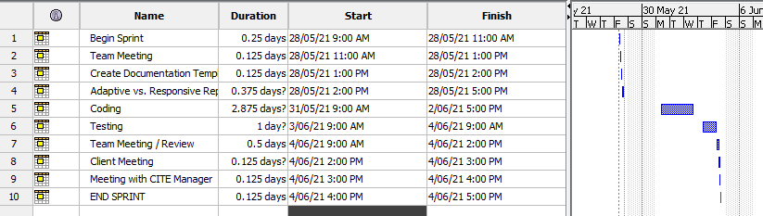

Figure - Project Management for sprint One

## Trello (Kanban Board)

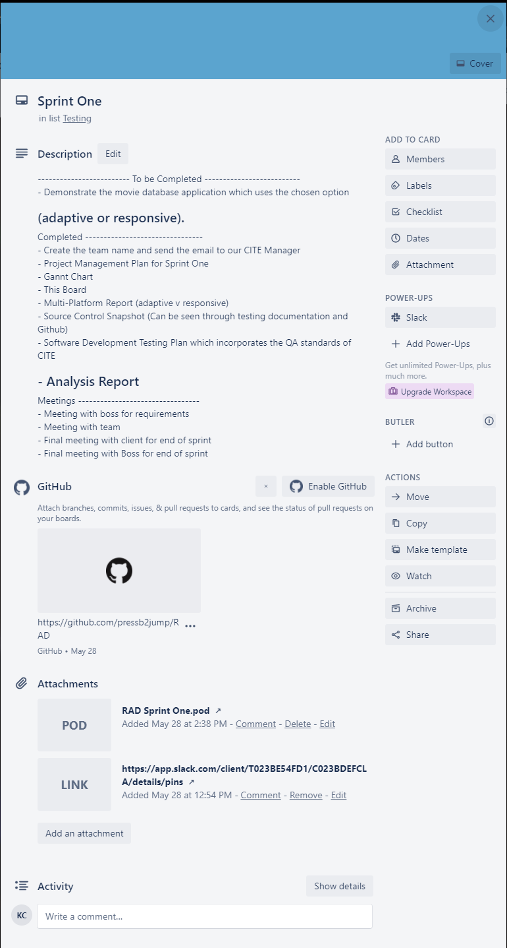This is the collaborative environment called Trello and includes all of the issues left to do.

# Client meeting Notes

- he gets it (Apdaptive vs responsive)

- does not like top 10. can't see it all on the one screen. (Wants to see table)

Wants

- admin portal

- capture newsletters. user sign up to send users junk mail.

- report on code optimisers (performance tools) man

# CITE Manager Notes

The meeting with out CITE Manager has indicated that as Scrum Master Kyle Chamberlain did not perform during the client meeting as well as he could have.

Overall, the meeting seemed to go okay and the expectation of the team for the next sprint is within scope.

Sprint 2

|  |  |
| --- | --- |
| Source Control Snapshot 04/06 – 11/06 | |
|  |  |

# 1 Introduction

This is a test plan for the movie database and website project for Acme Entertainment Pty Ltd. The software methodology used for this project is Rapid Application Development (RAD) and the testing methods are mentioned throughout this document for the current sprint.

## 1.1 Scope

### 1.1.1 In Scope

### The signup will not require a password but there must be an option to remove their subscription. The removal process should send an email to the administrator requesting the removal of a member’s details from the database. Create a membership page to add new records to a membership database

### 1.1.2 Out of Scope

Anything that is not mentioned in the scope is considered out of the testing scope.

## 1.2 Quality Objective

We have established processes that evaluate project performance and aim to assure that quality standards are being followed and that the deliverables comply with customer requirements. We measure performance trends to identify defective pieces of code, verify that deliverables are of high quality and that they are complete and correct.

## 1.3 Roles and Responsibilities

The scrum master for this sprint is Bayley Wise and is responsible for the final say on all issues of this sprint.

# 2 Test Methodology

## 2.1 Overview

The software methodology that is being used for this project is, Rapid Application Development. This method combined with Verification and validation software testing will be used. In the field of software engineering, the term verification, generally refers to the assessment and evaluation of the process or approach, which is carried out in the development of the software product, to build the desired product. Validation is all about, examination of the developed software product, to ensure the fulfilment of the pre-defined and specified requirements, such as software requirement specification (SRS), by the software product. This will be done each during sprint as well as at the end of the project.

## 2.2 Bug Triage

Bugs are defined as following:

Critical: Website does not load or will not integrate with the rest of the site.

Major: a function is not working and effects the webpage or does not meet requirements.

Minor: small bug that only affects something minor on the page but does not impact performance of the webpage.

## 2.3 Suspension Criteria and Resumption Requirements

Suspension of all other coding is to occur when a Critical bug is found. Other coding can be resumed once the critical bug has been successfully fixed. Major bugs should be attempted to be fixed by the end of the sprint or will be moved to the start of the next sprint.

## 2.4 Test Completeness

All test will try to have 100% coverage for the requirements that has been specified according to the scope.

# 3 Test Deliverables

The tests will be carried out with accordance to this test plan and will be documented in a test case document.

# 4 Resource & Environment Needs

## 4.1 Testing Tools

Most testing will be user testing and bugs will be tracked using GitHub and possibly Trello.

## 4.2 Test Environment

- The website will be hosted using USBWebServer.

- Database will be hosted using MySql.

- Website will be tested on at least 2 browsers (Chrome and Microsoft Edge).

# 5 Performance Report

## 5.1 Introduction

This is a performance report for the movie database and website project for Acme Entertainment Pty Ltd. The report will touch code optimizers and what they are and performance tools and what they are.

## 5.2 Code Optimizers

Code optimization is a technique, which tries to improve the intermediate code by making it consume fewer resources (for example. CPU, Memory) so that faster-running machine code will result. Optimization of the code is often performed at the end of the development stage since it reduces readability and adds code that is used to increase the performance.

An example of a PHP code optimizer is CodeSniffer. CodeSniffer sniffs through the source code and detects violations in syntax or defined set of coding standards. Along with PHP, it works for JavaScript and CSS files.

## 5.3 Performance tools

When developing with PHP it is highly advisable that every application you build should have the right PHP performance testing tools to ensure that it runs correctly. PHP profilers have been widely used by developers to improve PHP performance or to determine weak points of web applications. There are two types of code profilers: standard and tracing profilers.

Standard profilers periodically record stack traces of your application, while tracing profilers are lighter weight than standard profiles and can be used while you code. Standard code profilers give you a snapshot of important metrics like CPU, memory usage, time spent per line of code, and frequency of method calls. On the other hand, tracing profilers have quite an advantage from standard as you can use it every day, and it will not slow you down. It is designed to catch errors in real time while you are developing, instead of catching errors after the fact. Tracing profilers are considered as your first line of defence in dealing with bugs.

# 6 Sprint Two Meeting Minutes

**Date**: 11/June/2021

**Time**: 10:00am

**Facilitator**: Bayley Wise

# In Attendance

Bayley Wise (Scrum Master, Developer)

Kyle Chamberlain (Developer)

Andrew Samway (CITE Manager)

# Approval of Minutes

This is the first sprint meeting and it being approved by the Scrum Master

## Performance Report

CITE Manager requires a report to be written for the client to be presented at the next meeting. This must bring information about multi-platform issues.

## Source Control Snapshot

CITE Manager requires a source control versioning to be made for record keeping purposes.

## Project Management Plan

CITE Manager requires a project management plan to be made so as to show what the expectations are for each week and to keep accountability so as to reduce time wastage and realism for the client.

## Testing Plan

A testing plan for the developers must be made and kept to

## Client Meeting

This meeting will be called for next week by Kyle Chamberlain, please ensure you are allowing time for the project to be made as well and keeping time for the next sprint with the client.

## Sprint Report

Bayley Wise Presented as SCRUM Master with Kyle Chamberlain as an attendee.

# Project Management

## Gannt Chart

Figure 2 - Project Management for sprint Two

## Trello (Kanban Board)

This is the collaborative environment called Trello and includes all of the issues left to do.

# Client meeting Notes

- Missing checkboxes for newsletter or news blast

- does not like colours

Wants

- admin password complexity

- Home page

- report on optimisers used

- Logo on every page

Sprint 3

|  |  |
| --- | --- |
|  |  |
|  |  |
|  |  |

# 1 Introduction

This is a test plan for the movie database and website project for Acme Entertainment Pty Ltd. The software methodology used for this project is Rapid Application Development (RAD) and the testing methods are mentioned throughout this document for the current sprint.

## 1.1 Scope

### 1.1.1 In Scope

Create the appropriate users and groups in the movie database so administrators can log on securely using a password. The password must pass a minimum complexity test. Create a query that will calculate the top 10 most popular movies each time the Top 10 web page is opened. The query should also update when a user adds a rating to a movie. The data from the top 10 movies should be appended to a new streaming table in the movie database each time there is a change in the top 10 ratings. Using the data from the streaming table to create a chart front end to display the data.

### 1.1.2 Out of Scope

Anything that is not mentioned in the scope is considered out of the testing scope.

## 1.2 Quality Objective

We have established processes that evaluate project performance and aim to assure that quality standards are being followed and that the deliverables comply with customer requirements. We measure performance trends to identify defective pieces of code, verify that deliverables are of high quality and that they are complete and correct.

## 1.3 Roles and Responsibilities

The scrum master for this sprint is Kyle Chamberlain and is responsible for the final say on all issues of this sprint.

# 2 Test Methodology

## 2.1 Overview

The software methodology that is being used for this project is, Rapid Application Development. This method combined with Verification and validation software testing will be used. In the field of software engineering, the term verification, generally refers to the assessment and evaluation of the process or approach, which is carried out in the development of the software product, to build the desired product. Validation is all about, examination of the developed software product, to ensure the fulfilment of the pre-defined and specified requirements, such as software requirement specification (SRS), by the software product. This will be done each during sprint as well as at the end of the project.

## 2.2 Bug Triage

Bugs are defined as following:

Critical: Website does not load or will not integrate with the rest of the site.

Major: a function is not working and effects the webpage or does not meet requirements.

Minor: small bug that only affects something minor on the page but does not impact performance of the webpage.

## 2.3 Suspension Criteria and Resumption Requirements

Suspension of all other coding is to occur when a Critical bug is found. Other coding can be resumed once the critical bug has been successfully fixed. Major bugs should be attempted to be fixed by the end of the sprint or will be moved to the start of the next sprint.

## 2.4 Test Completeness

All test will try to have 100% coverage for the requirements that has been specified according to the scope.

# 3 Test Deliverables

The tests will be carried out with accordance to this test plan and will be documented in a test case document.

# 4 Resource & Environment Needs

## 4.1 Testing Tools

Most testing will be user testing and bugs will be tracked using GitHub and possibly Trello.

## 4.2 Test Environment

- The website will be hosted using USBWebServer.

- Database will be hosted using MySql.

- Website will be tested on at least 2 browsers (Chrome and Microsoft Edge).

# Optimization Report

## What is a code optimizer?

Code optimization is a transformation technique used to improve code. This can be done by reducing the resources being used. Some goals that should be achieved during code optimization are;

* The optimisation of code should not change the way the program functions as a whole.
* It should increase the speed and overall performance of code.
* Compiler time must be relatively quick and does not increase the delay for overall compiling.

Code should be optimized at the end stage of the development process. Since we are nearing an end for this project the code will be getting optimized. For this we will be looking at various types of optimization.

### Machine Independent Optimization

This is optimization phase improves intermediate code so as to get a better target code being output.

### Machine Dependent optimization

This is done after the target code has been generated.

## Examples of Code Optimizers

* PHP CodeSniffer
* Atoum
* PHPSpec

## PHPCodeSniffer

For this project we will be using the PEAR Code Standard. This is an industry standard that both optimizes code as well as maintaining a certain readability for developers. Each time that the code is optimized a report is made showing where all non-pear code standard blocks are and how they need to be fixed. This is a great tool for developers.

# Sprint Three Meeting Minutes

**Date**: 18/June/2021

**Time**: 10:00am

**Facilitator**: Kyle Chamberlain

# In Attendance

Bayley Wise (Developer)

Kyle Chamberlain (Developer, Scrum Master)

Andrew Samway (CITE Manager)

# Approval of Minutes

This is the first sprint meeting and it being approved by the Scrum Master

## Performance Report

CITE Manager requires a report to be written for the client to be presented at the next meeting. This must bring information about multi-platform issues.

## Source Control Snapshot

CITE Manager requires a source control versioning to be made for record keeping purposes.

## Project Management Plan

CITE Manager requires a project management plan to be made so as to show what the expectations are for each week and to keep accountability so as to reduce time wastage and realism for the client.

## Testing Plan

A testing plan for the developers must be made and kept to

## Client Meeting

This meeting will be called for next week by Kyle Chamberlain, please ensure you are allowing time for the project to be made as well and keeping time for the next sprint with the client.

## Sprint Report

Bayley Wise Presented as SCRUM Master with Kyle Chamberlain as an attendee.

# Project Management

## Gannt Chart